1. Write a program to print the prime factors of numbers in an array.

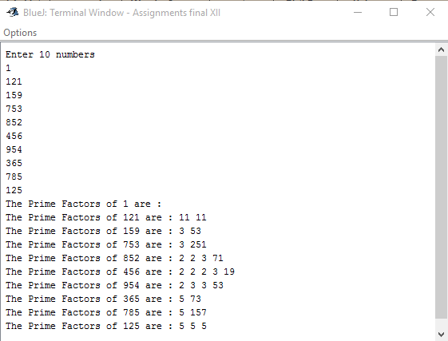

1. Write a program to decrypt input strings using an input shift value.

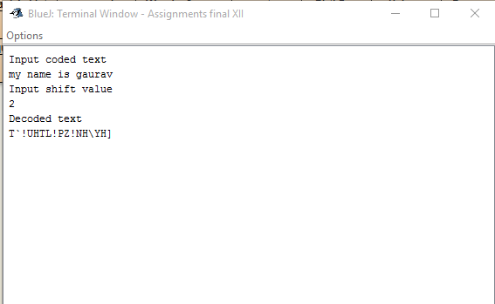

1. Write a program to accept a string and print its pig-Latin equivalent.

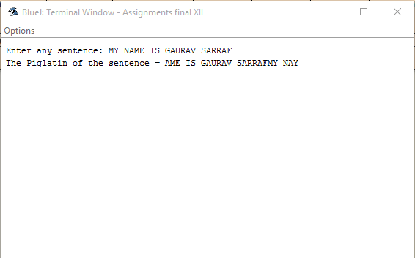

1. Write a program to input an array of any size, sort it using bubble sort technique and search for a particular value in the array using binary search technique.

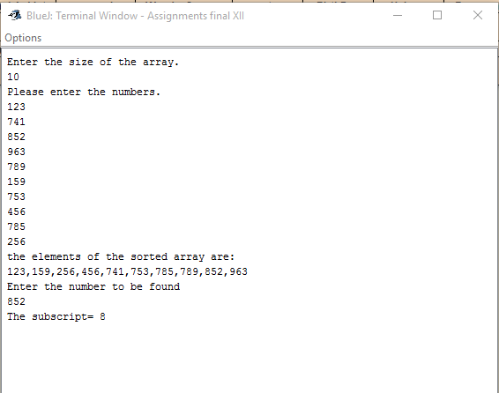

1. Write a program to input a number and print its equivalent roman numeral.

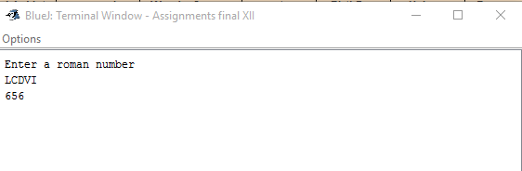

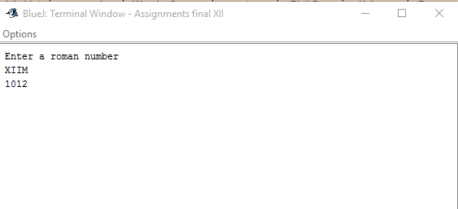

1. Write a program to accept a date and count the number of days from 1st of January to the date entered.

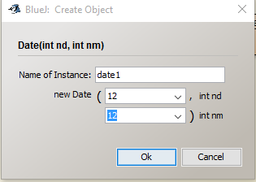 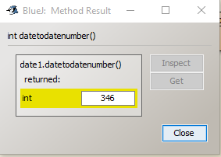

1. Write a program to compute the fine for returning a book late to a library. Show the implementation of Inheritance.

1. Write a program to create a stack as an array, push, pop and display values in it.

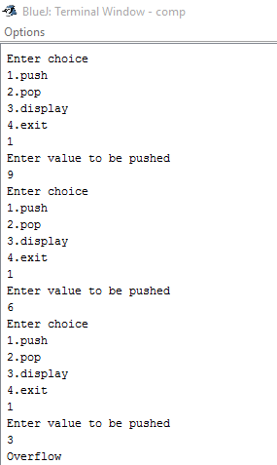 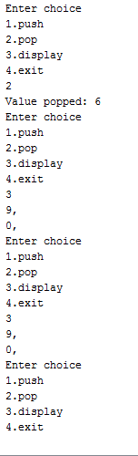

1. Write a program to input a string, reverse it using recursive technique and check if it’s a palindrome.

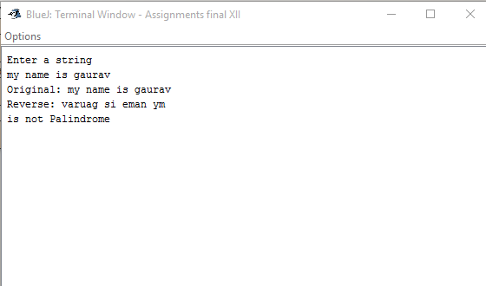

1. Write a program to accept a number n and print the spiral form of a matrix from n2 to 1.

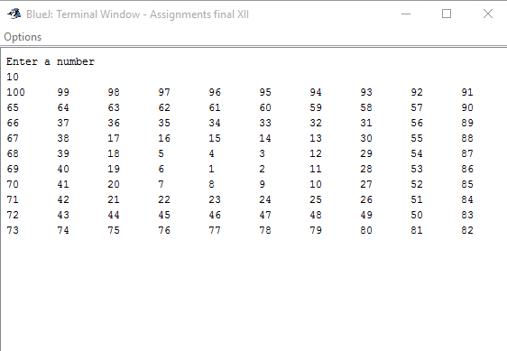

1. Write a program to create a queue as an array, insert, delete and display elements.

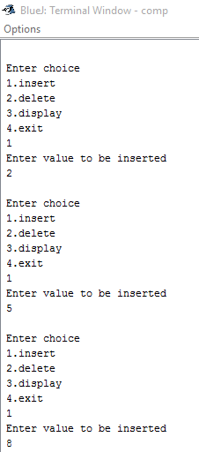 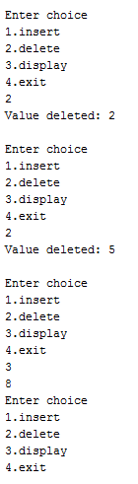

1. Write a program to input integers into an array, using recursion, sort it with selection sort technique and print.

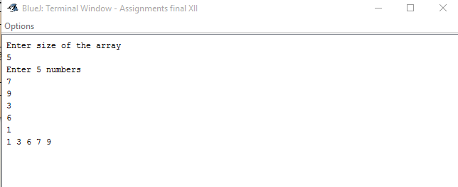

1. Write a program to count the number of capital vowels in a string using recursive technique.

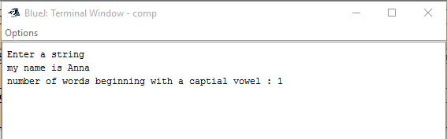

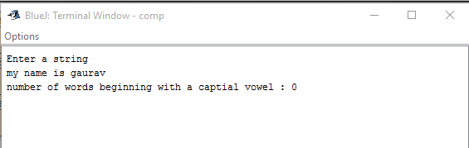

1. Write a program to find the factorial of a given number using recursion technique.

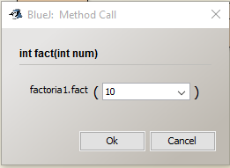 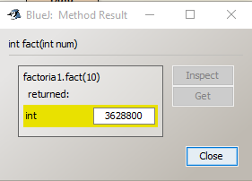

1. Write a program to create a stack with linked list implementation, push, pop and display values in it.

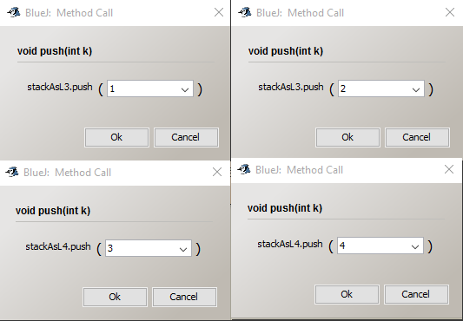

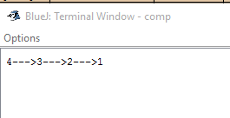

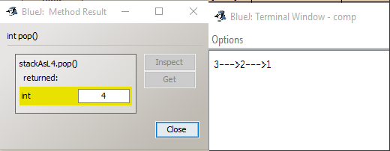

1. Write a program to find the sum of the series x2/11 + x4/22 + x6/33 +…. using recursion technique.
2. Write a program to check if a give matrix is a wondrous square.

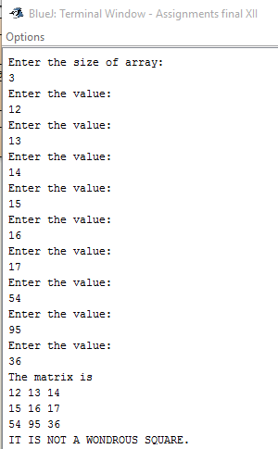 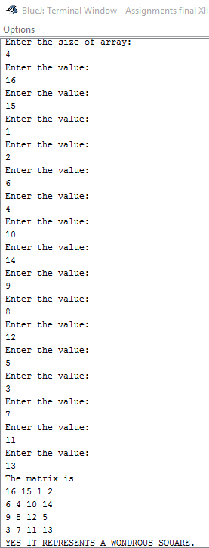

1. Write a program to input 100 integers in an array, sort it using selection sort technique and print.

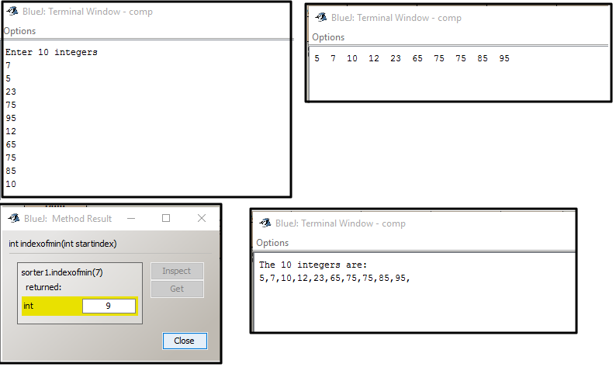

1. Write a program to input a birthday and print the day of the year.

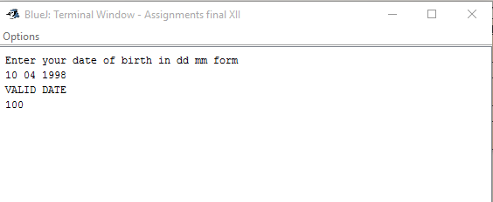

1. Write a program to print a unique numbers in a range.

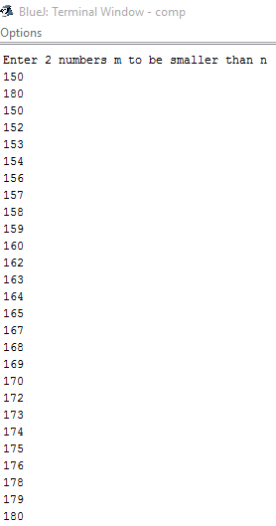

1. Write a program to create and abstract class Employee and a subclass Programmer to calculate salary. Implement the concept of inheritance.
2. Write a program to input two points with x and y coordinates and find the distance between them.

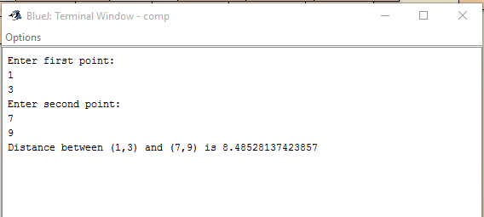

1. Write a program to find the difference in days between two dates.

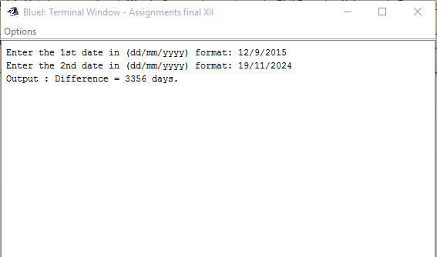

1. Write a program to create a text file, store some lines of text and read from it.

**Write: Read:**

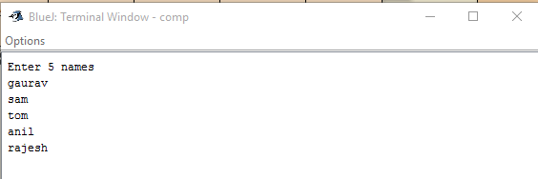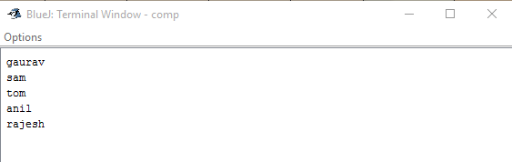

1. Write a program to create a Double ended queue, method for insertion and deletion from both ends and a display method.

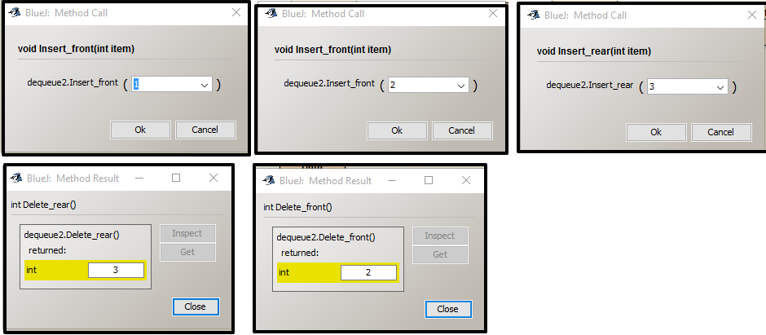

1. Write a program creating a super class Data and a subclass Process to print and count the words beginning with a vowel in a string.

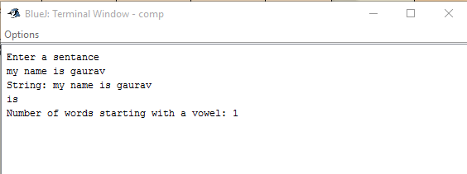

1. Write a program to create a linked list implemented as a queue, insert, delete and display elements in it.

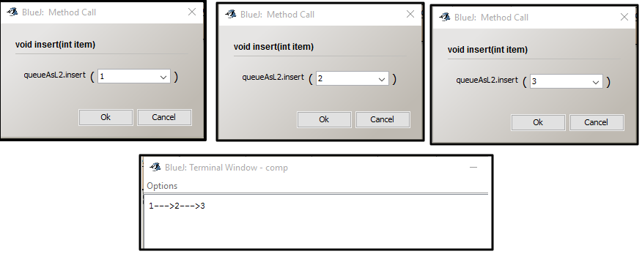

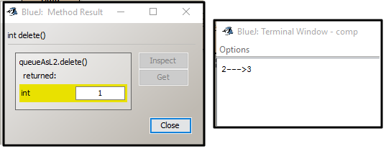

1. Write a program to create a binary file which stores the marks obtained by students, read and write from the file.

**Write: Read:**

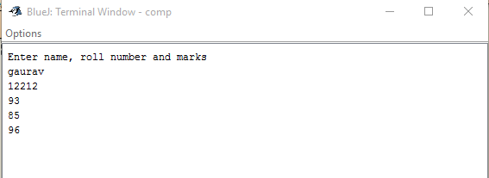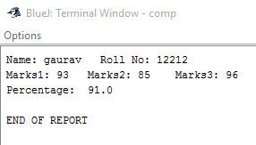

1. Write a program to find the saddle point of a matrix.

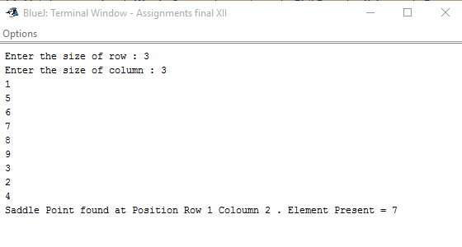

1. Write a program to print only the magic numbers in given array of any size.

